Rabbi’s Report – Board Meeting
November 15, 2018
- We are still seeking a weekly teacher for our youngest students in First Grade but we are filling in with me. Guest presenters Ned Rubin (on mental health and how it relates to justice and the courts), Joanne Turnbull (on peace), and Pastor Linda Mervine (on being neighbors) have enjoyed coming to speak to the Machon students. We are developing our security monitoring schedule for the year.
- I am working with the Social Action committee to plan our annual interreligious dialogue program on November 18 at 2:00 pm. Presenters will include Pastor Jared Carson (Lutheran), Pastor Donna Cavedon (United Church of Christ), the Rev. Carol Tuck (United Methodist), Fr. Ron Catherson (Independent Catholic-Apostolic Church of Antioch), Harvey Hilbert (Buddhist), Gordon Butler (Baha’i), and others will be discussion group leaders. I am working on discussion group questions over the next couple of days.
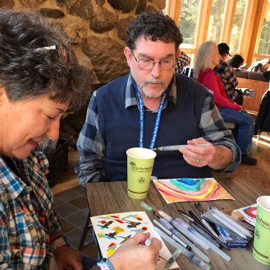
- My time at Shabbat Shira at Olin-Sang-Ruby Camp in Oconomowoc, Wisconsin on November 1-4, 2018 gave me an opportunity to learn many new songs and melodies for prayerbook texts and to see how our faculty led our worship. I was one of 70 participants this year. Julie Silver led a session on painting/art as spiritual expression on Friday morning – I was caught on camera adding some touches to one of my pieces that I created that morning.
- I am keeping track of and visiting congregants who are in local rehabilitation facilities and in the hospital.
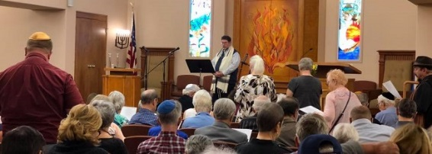
- I attended the celebration of life for Sherlyn Shervanick on Sunday, November 11. I shared a few words of tribute and lead a prayer and reading before lighting a memorial candle.
- I visited El Paso on Wednesday and Thursday this week while some of my rabbinic colleagues from around the country traveled to the area to assist refugees and asylum seekers in various ways.
- I joined Robert French (Jewish Federation of Greater El Paso), Rabbi Ben Zeidman (Temple Mount Sinai), and Rabbi Scott Rosenberg (Congregation B’nai Zion) for lunch in El paso yesterday to discuss a full agenda of items related to our work in the community separately and together.
- Rose Jacobs is partnering with me to update our Temple directory, with the final result ready by Chanukah, we hope.
- I am continuing to write a column for the Las Cruces Bulletin on the first Friday of the month.
- I was asked by the New Mexico Jewish Historical Society to write an article for their LEGACY newsletter about interfaith activities in Las Cruces for their January issue. I have begun to create an outline for the article.
- I continue to coordinate a monthly clergy breakfast on the third Thursday of the month. We had added a clergy book discussion group on Parker Palmer’s Healing the Heart of Democracy. I am serving as a representative on the NMSU Interfaith Council. I attend a noon interreligious book study group on Fridays, now discussing Reza Aslan’s God: A Human History. I serve on the Las Cruces Health Policy Review Committee, which meets on the third Thursday of the month at 10 am at City Hall.
- who offered the benediction at the service.
- I completed a five-session online class on “Writing Contemporary Liturgy” with Alden Solovy on November 13. We learned different approaches and strategies on how to write prayers and how to choose themes of prayers, and commented on each other’s writing.
- I plan to attend the Pacific Association of Reform Rabbis convention on January 6-10 in Palm Springs, CA and the Central Conference of American Rabbis convention in Cincinnati, Ohio on March 31-April 3.
- I found the October 28 session on Defining Spirituality, within the context of the Leadership series, to be challenging and enlightening. I intended to broaden people’s perspectives on what spirituality is and how it relates to some of the values we hope to exhibit as leaders. I hope that the session helped in that process of growth.
- The October 28 memorial/vigil after the attack on Tree of Life synagogue was an overwhelming and gratifying experience. My thanks to congregants who were able to attend as part of our congregation for the day of 180 people. It was an important event and we were warmed by the community support we received.

