Rabbi’s Report –Board Meeting
August 17, 2016
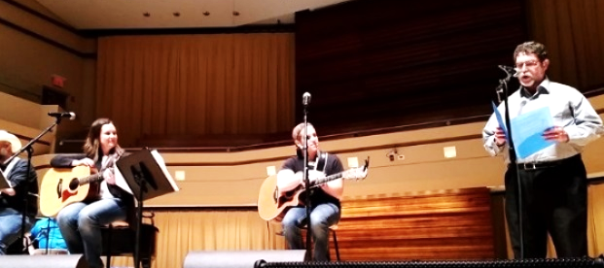
- I have been working with Pearie Bruder and the Religious School faculty to get our school year off to a good start. We will have an orientation meeting on Sunday, August 28 at 10am, a change that was made due to faculty members who will be away for the originally planned first and second sessions.
- The Religious Practices committee met to discuss thoughts about worship services and to prepare the mailing for High Holy Days that was sent out on Tuesday. We have commitments to purchase 35 more copies of the new High Holy Day prayerbook, Mishkan Hanefesh, for this year. I sent out an email asking others in the congregation if they would like to purchases this prayerbook for Temple over the next two weeks.
- I will be leading a session on Rabbi Jill Jacobs’ There Shall Be No Needy on Monday, August 22 at 7pm.
- I am serving on the Children’s Reading Alliance by-laws revision committee as a community representative. I continue to convene a monthly Third Thursday clergy breakfast. There will be an initial community program for the Las Cruces Interfaith Coalition for Compassion happening on August 23 at Community Action on Foothills on the topic of Respect.
- There will be a celebration of International Peace Day at Young Park on Wednesday, September 21 at 6:00-9:00 pm. I will be taking part in the program at some point during the evening.
- A group in El Paso is sponsoring “Day of Song/Yom Shir,” featuring Jewish Blues artist Saul Kaye, on September 25. I will be attending and performing as well. On September 18, at 4:00-6:00 pm, the El Paso Jewish Federation will sponsor “Shofars Across Borders” at Border Monument 1. They are asking for communities to provide entertainment for the program. I will attend and also see what I can arrange from here.
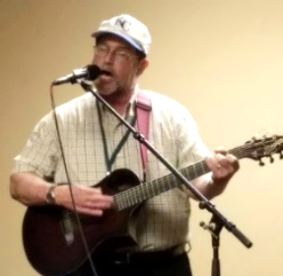
- I attended NewCAJE, a conference for Jewish Educators, at North Central College in Naperville, Illinois on July 31-August 3. I attended session on Compassion and Judaism, Grandparents and tzedakah in their extended family, Saying I’m Sorry-a study of prayers for the High Holy days, the Book of Jonah, Grownups are different (how adults learn), Love the stranger – the Jewish and other immigrant experiences, teaching Comparative Religion, the soul of Jewish prayer, and Dynamics of Dialogue. I was asked by Rick Recht to share some thoughts during the evening program he produced on the last night of the convention, and had a chance to sing an original song at a late-night venue.
- Washington, D.C. based singer/guitarist Robyn Helzner contacted me about coming to Las Cruces on Monday, January 23 (after appearing at a program in Phoenix the night before). She
- would charge $500 for the program and $150 for her flight from Phoenix to El Paso. I could get her from the airport and take her back the next day. We could either put her up for the night in a hotel or provide home hospitality. She does not require a rental car. She will likely want to see CDs. The program she would do is called “Kreplach and Dim Sum – Yes, there ARE Jews in China!”, a presentation with music and a power point with photos and videos. I saw the program in Albuquerque in April and it is excellent. It is rare to have a world-renowned Jewish performer be available for less than $1000. I would like to set that date with Robyn and put the event on the calendar.
- I will be co-officiating at my brother’s wedding on Labor Day weekend. I will arrange for service substitutes for Friday night and Shabbat morning for that weekend.
- I reserved a shelter house at Veterans Memorial Park for our annual Shabbat in the Park on Friday, September 9 today with the Las Cruces Parks and Recreation Department. However, they have one additional requirement this year – their department needs to be shown on our insurance for that one day if the service is going to be noted on any document that could be seen by the general public (Facebook, Adelante on our website, Temple calendar on the website). I have contacted Pat Campbell Insurance to see what this entails (their computers were down at the time). Going ahead with the service at the park will depend on the additional cost that may be added to our insurance, but there may be no additional cost. I will keep you posted.

