Rabbi’s Report – Board Meeting
December 13, 2018
- I have continued to teach First Grade (Amelia Flores is the student) in the Religious School with Casey Rosenberg as my regular madrichah/aide. Nicole Martinez will be a guest presenter for Machon on Sunday, December 16. Kari Lenander, director of Border Servant Corps, will speak about her organization and community work on January 27. Parents are signing up to provide security monitoring each week. Sarah Mindlin’s and Rhonda Karol’s classes are going well, both for Hebrew and their core studies (Bible for Sarah, History for Rhonda). Several students participated in the Shabbat Chanukah service (per my request of parents and students).
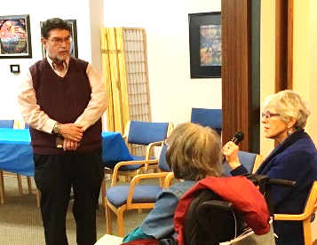
- The annual interreligious dialogue program on November 18 was attended by 65 people from Temple (including 20 congregants) and the community. Presenters included Pastor Jared Carson (Lutheran), Pastor Donna Cavedon (United Church of Christ), the Rev. Carol Tuck (United Methodist), Fr. Ron Catherson (Independent Catholic-Apostolic Church of Antioch), Harvey Hilbert (Buddhist), and Gordon Butler (Baha’i). They served as small group discussion leaders, as did Pastor Linda Mervine and I. It was a well-received program, which was supported and sponsored by the Social Action/Adult Education committee.
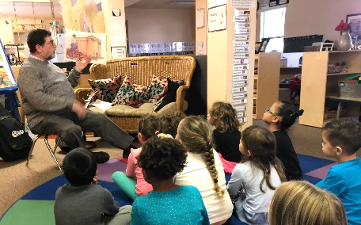
- I have three students in my Introduction to Judaism course. Our Tanakh Study session on Wednesdays brings together several congregants and several more community members, including Father Gabriel Rochelle of St. Anthony of the Desert Orthodox Mission (several of his members attended regularly).
- I offered a presentation on Chanukah at the Las Cruces Public Schools Amistad Pre-School on Thursday, December 6 (where Rhonda teaches).
- I participated in the program at the Community-Wide Celebration of Chanukah in El Paso at San Jacinto Plaza on Sunday, December 9. Neal Rosendorf, chair of the event, asked me to sing, so I sang “Light One Candle.” There was a strong showing from their community. Bob and Monika Kimball were there as well.
- I presented on Judaism to a Cub scout group on Tuesday, December 11 at Morningstar United Methodist Church.
- I am keeping track of and visiting congregants who are in local rehabilitation facilities and in the hospital.
- I will again join Robert French (Jewish Federation of Greater El Paso), Rabbi Ben Zeidman (Temple Mount Sinai), and Rabbi Scott Rosenberg (Congregation B’nai Zion) for lunch in El Paso on January 3, 2019.
- Rose Jacobs is partnering with me to update our Temple directory. We will ask congregants who have not responded to correct and confirm their listing.
- I am continuing to write a column for the Las Cruces Bulletin on the first Friday of the month.
- I submitted the rabbi’s column for the January issue of the El Paso Jewish Voice.
- I have written an article for the January issue of the New Mexico Jewish Historical Society LEGACY newsletter about interfaith activities in Las Cruces.
- I attended the November 29 meeting of the NMSU Interfaith Council, of which I am still a member.
- I continue to coordinate a monthly clergy breakfast on the third Thursday of the month. I attend a noon interreligious book study group on Fridays, now discussing Karen Armstrong’s The Battle for God. I serve on the Las Cruces Health Policy Review Committee, which meets on the third Thursday of the month at 10 am at City Hall.
- I plan to attend the Pacific Association of Reform Rabbis convention on January 6-10 in Palm Springs, CA and the Central Conference of American Rabbis convention in Cincinnati, Ohio on March 31-April 3.
- It is the responsibility of the Board of Trustees to set a “ceiling” amount for the portion of my salary that is designated as a parsonage allowance in keeping with the code of the Internal Revenue Service, which allows clergy to set aside expenses for a home and its upkeep to be tax-excludable. I have asked the board to set $19,000 for each calendar year as my parsonage allowance in the last few years, and I am making a request for that same amount of $19,000 for the Calendar Year of 2019. I can only declare as parsonage the total amount of expenses I spend on housing up to $19k.

